Cloud Architect, Data Analyst

Analytics

**Lab Details**

1. This lab walks you through the steps to query the data present in S3 Bucket with Amazon Athena.
2. You will practice using Amazon Athena to create a table with a CSV file present in the S3 bucket and query using SQL statements.
3. Duration: **1 hour**
4. AWS Region: **US East (N. Virginia) us-east-1**

**Introduction**

What is Amazon Athena?

1. Amazon Athena provides an interactive query editor where you can easily analyze data present in S3 Bucket using SQL statements.
2. Since this is a serverless service, you will only be charged for the queries that you run.
3. In the backend, Amazon Athena uses Presto which supports standard SQL statements and works with different flavors of standard data formats, which includes CSV, ORC, JSON, Arvo and Apache Parquet.
4. You can access Athena with AWS Management console, ODBC / JDBC drivers or API.

**Architecture Diagram**

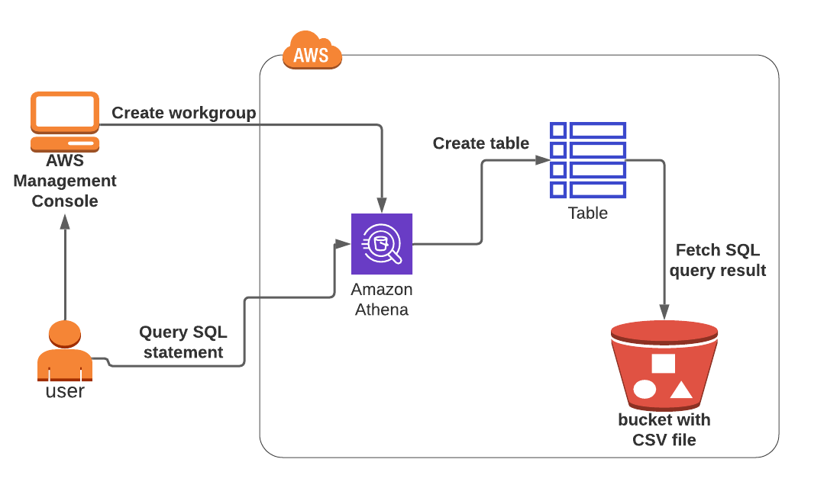

Task Details

1. Sign into AWS Management Console.
2. Setup workgroup
3. Create a database in Glue.
4. Query table in Athena
5. Validation of the lab
6. Deleting AWS Resources

**Launching Lab Environment**

     1. To launch the lab environment, Click on the  button.

     2. Please wait until the cloud environment is provisioned. It will take less than a minute to provision.

     3. Once the Lab is started, you will be provided with **IAM user name**, **Password**, **Access** **Key**, and **Secret** **Access** **Key**.

**Note** : You can only start one lab at any given time